VCC Stakeholders and Sponsors Sticker Order Form
General Alt Fuel : FAX This Form to Alleyn Harned at 540-568-5181

Qty. | Sticker | Size | Picture | Ship to:
 | Clean Alternative Fuel Vehicle (truck or bus)  Catalog #4076 | 12" X 12" |  | Name:  Street Address:  City, State, Zip:  Phone number:  Email address:  Partner Sticker Contact  DOE NREL  FAX 303-630-2125.  judi.deitchel@nrel.gov
 | Clean Alternative Fuel (pump)  Catalog #4075 | 12" X 12"
 | Clean Alternative Fuel Vehicle (bus)  Catalog #4077 | 23" X 7.25"
 | Clean Advanced Technology Vehicle (for hybrids or plug-in hybrid vehicles)  Catalog #4221 | 12" X 12"
 | Clean Advanced Technology Vehicle (clear window cling) (for hybrids or plug-in hybrid vehicles  Catalog #4222 | 6" X 6"
 | Clean Alternative Fuel Vehicle (clear window cling)  Catalog #4090 | 6" X 6" | 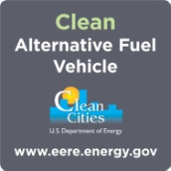
 | Clean Alternative Fuel Clean Cities (decal for charging stations)  Catalog #5328 | 4" X 4"
Biodiesel Stickers FAX This Order Form to Alleyn Harned at 540-568-5181

No. Requested | Sticker | Size | Picture
 | 6020 Large Biodiesel Bumper sticker NBB | 3 ¼ x 12 ½ self adhesive bumper sticker.
 | Fuel and Tanker Truck “Powered By” Stickers NBB | Heavy duty, adhesive sticker that can be placed on fuel tanks and/or tanker trucks. 7” tall and 16” wide logo on white, perm pressure, all-weather vinyl with UV ink, square corners.
 | 6040 Biodiesel Sticker (Yellow) | 5 ¾ x 7 oval cut self adhesive sticker, white background
 | B-100 Biodiesel Blend Sticker | Required for neat biodiesel B 100- Approved by the FTC and required on biodiesel pumps | 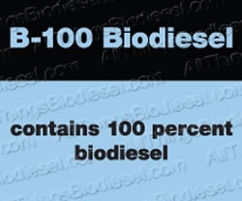
 | B20 Blend Sticker | Required for neat biodiesel B 5 to 20% Approved by the FTC and required on biodiesel pumps | 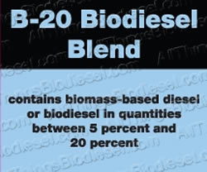
 | Biodiesel Stick-on Emblem - $25 Requires purchase | Each letter is approximately 1” by 1”

Name
Street Address
City, State, ZIP
Phone No.
Email Address
Ethanol and E85 Stickers
Fax This Order Form to Alleyn Harned at 540-568-5181

No. Requested | Sticker | Size | Picture
 | Stop Label – Reminder, fuel for FFV only | 4 x5 self adhesive label | 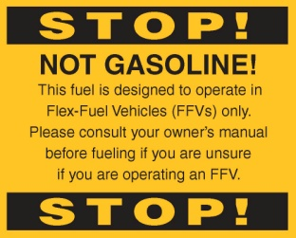
 | E85 Pump Label | 3x3 adhesive label | 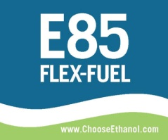
 | E85 ethanol Flex fuel pump label | 3x3 adhesive label | 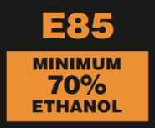
 | Ethanol – Fueled with Pride | 3x3 adhesive label – circular with white background
 | E20 ethanol Flex fuel pump label | 3x3 adhesive label | 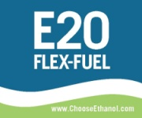
 | E30 ethanol Flex fuel pump label | 3x3 adhesive label
 | E40 ethanol Flex fuel pump label | 3x3 adhesive label | 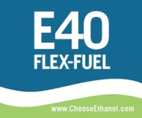

Name
Street Address
City, State, ZIP
Phone No.
Email Address
Recovery Act Stickers and Clings
FAX This Order Form to Alleyn Harned at 540-568-5181
No. Requested | Sticker | Size | Picture
 | Clean Alternative Fuel Vehicle with Recovery.gov logo (truck or bus) (ID# 4652) | 14" x 6.5" | 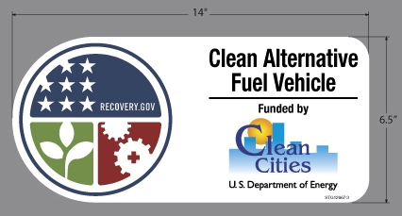
 | Clean Advanced Vehicle with Recovery.gov logo (hybrid or plug-in hybrid vehicle) (ID#4651) | 14" X 6.5" | 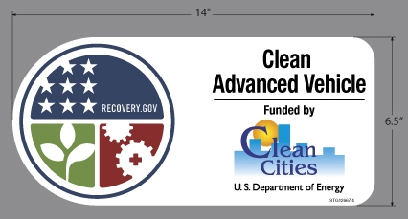
Name
Street Address
City, State, ZIP
Phone No.
Email Address

CNG and LPG stickers – Fax to Alleyn Harned at 540-568-5181

No. Requested | Sticker | Size | Picture
 | CNG “Diamond Sticker”. They meet the full FMVSS Requirement as reflective decals. * this is $6 |  | 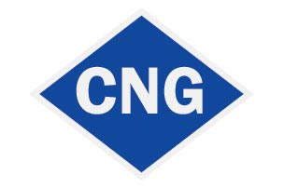
 | Peace, Love, and Natural Gas/PASS IT ON. cngnow.com
 | Save Money and the planet . cngnow.com
 | Save money, clean the air, create American jobs. cngnow.com
 | My money stays in America/ I DRIVE A NGV. cngnow.com
 | LPG Autogas “Diamond Sticker”. Meets full FMVSS requirement as reflective decals. * This is $6
 | 3-Dimensional Autogas badge.  *This one is $10 | 6” x 2 “ | 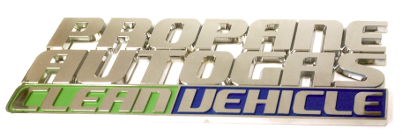

Name
Street Address
City, State, ZIP
Phone No.
Email Address

